1 INTRODUCTION:
1.1.Overview
Designing a logo is a creative process that involves creating a unique and visually appealing symbol or wordmark to represent a brand, company, or organization. It should be simple, memorable, and convey the essence of the entity it represents. Logos can include text, icons, or a combination of both and must be adaptable for various applications and sizes. Effective logo design considers color, typography, and shape to create a distinctive brand identity.
1.2 Purpose
Brand Identity: A well-designed logo is the cornerstone of a brand's visual identity. It helps consumers recognize and remember the brand.Recognition: Logos help in immediate brand recognition, which is vital in a competitive market.
Memorability: A good logo is memorable, making it easier for customers to recall the brand when making purchasing decisions
Marketing: Logos can be used in advertising and promotional materials, making them a crucial marketing asset.Consumer Loyalty: Over time, a logo can become synonymous with a positive brand experience, fostering customer
Legal Protection: Trademarking a logo provides legal protection against others using a similar design, safeguarding the brand's identity.
PROBLEM DEFINITION & DESIGN DHINKING
2.1 Empathy map
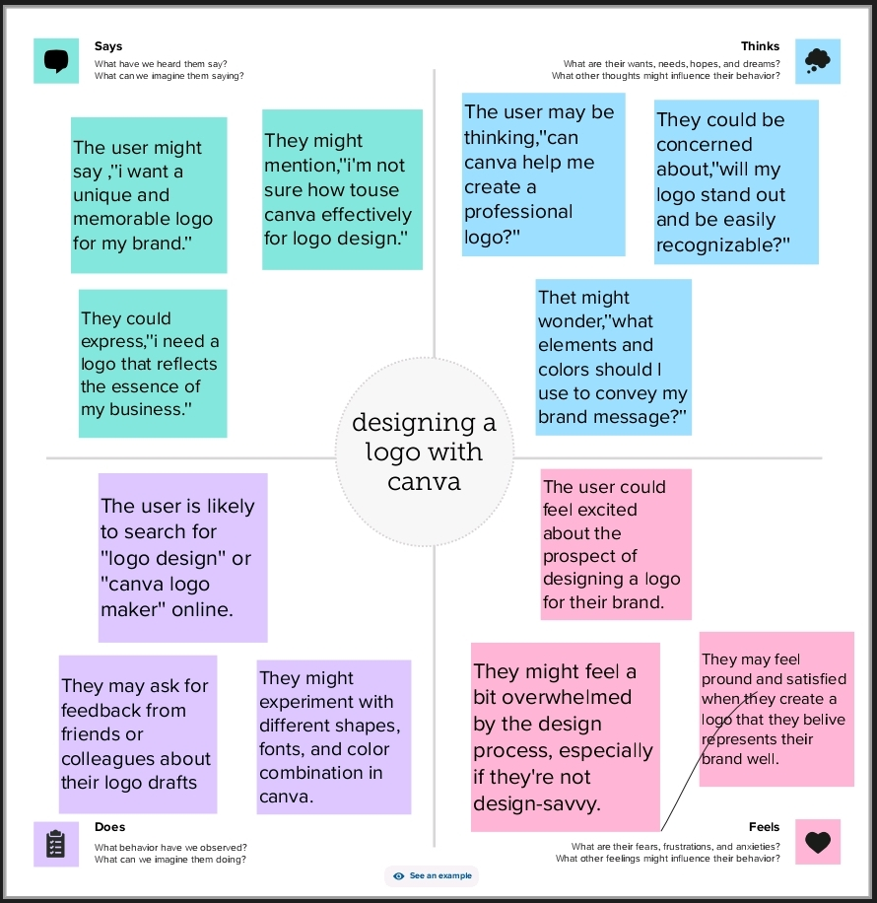
2.2 Ideation & Brainstorming map
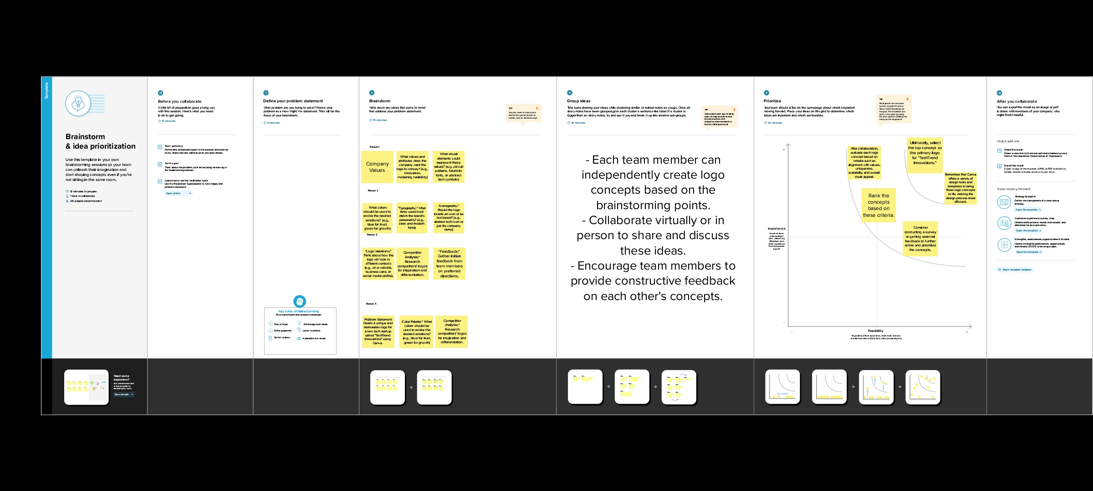
RESULT
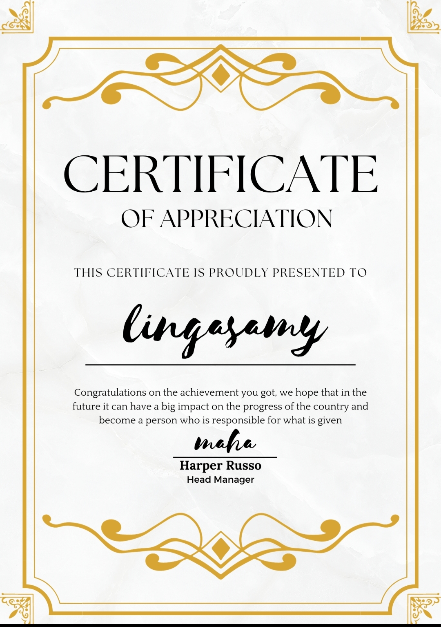

4.ADVANTAGES & DISADVANTAGES
Advantages:
Brand Recognition: A well-designed logo enhances brand recognition, making it easier for customers to identify and remember the brand.
Professionalism: A professionally designed logo can convey a sense of trust and credibility, encouraging customer confidence.
Differentiation: A unique logo helps the brand stand out from competitors in a crowded marketplace
Communication: Logos can effectively communicate the brand's values, personality, and message.
Disadvantages:

Cost: Professional logo design can be expensive, especially for startups or small businesses with limited budgets.

Time-Consuming: Designing a logo can be a time-consuming process, requiring careful consideration and creativity.
5.APPLICATIONS
Business Branding: Logos are essential for businesses of all sizes and types. They serve as a visual representation of the company and are used in marketing, on websites, and in all branding materials.
Product Branding: Companies often create individual logos for their products or product lines to differentiate them in the market.

Nonprofit Organizations: Nonprofits use logos to establish their identity and convey their mission and values to donors and supporters.
6.CONCLUSION
In conclusion, designing a logo is a fundamental aspect of branding and visual identity across a wide range of industries and applications. A well-crafted logo offers numerous advantages, including enhancing brand recognition, conveying professionalism, and differentiating a business or organization from its competitors. It serves as a powerful communication tool, enabling the portrayal of a brand's values and personality.
7.FUTURE SCOPE
Artificial Intelligence (AI) Integration: AI can assist in generating logo concepts and designs based on a brand's characteristics and preferences. This could streamline the design process and offer more personalized options.

3D and Interactive Logos: Advances in technology could enable the creation of logos that are interactive or 3D, enhancing the brand's online presence and user engagement.

Dynamic Logos: Logos that adapt to different contexts, such as changing colors or elements based on the platform or audience, could become more prevalent.
8 .APPENDIX
I apologize for any confusion, but logo design is primarily a graphic design process, and it doesn't involve traditional source code like that used in software development. Logo design is typically done using graphic design software, where designers create and manipulate visual elements, typography, and images to form a unique logo
https://www.canva.com/

